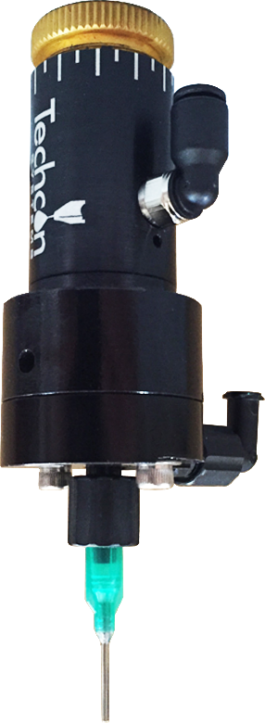



**Product Data Sheet**

NEW TS5624DMP Disposable Material Path Diaphragm Valve

The TS5624 Disposable Diaphragm Valve features a “first to market” Disposable Material Path. Difficult fluids such as CA’s and pre-mixed 2-part epoxies, can now be dispensed without the need of frequent cleaning, by simply replacing the entire wetted area in a matter of seconds, while the valve stays on the production line.

The wetted parts are manufactured from black Polyethylene to prevent moisture and UV light come into contact with the dispense fluids. As a result, moisture sensitive fluids such as Cyanoacrylate and UV cured adhesives can be dispensed reliably and accurately.

The TS5624 dispenses low to medium viscosity fluids over a wide range of shot and bead sizes, down to a fraction of a micro liter. An internal spring return makes the valves fully adaptable for use with Techcon Systems controllers. A short opening stroke provides an extremely fast and positive shut-off.

The seal-less valve design offers an excellent moisture sensitive resistance and the incorporated diaphragm creates a barrier between the wetted parts and the air cylinder.

**KEY FEATURES AND BENEFITS**

* Disposable material path – no cleaning
* Compact size and weight
* Excellent moisture sensitive resistance
* No special tools required
* Low cost of ownership
* Accurate and repeatable dispensing

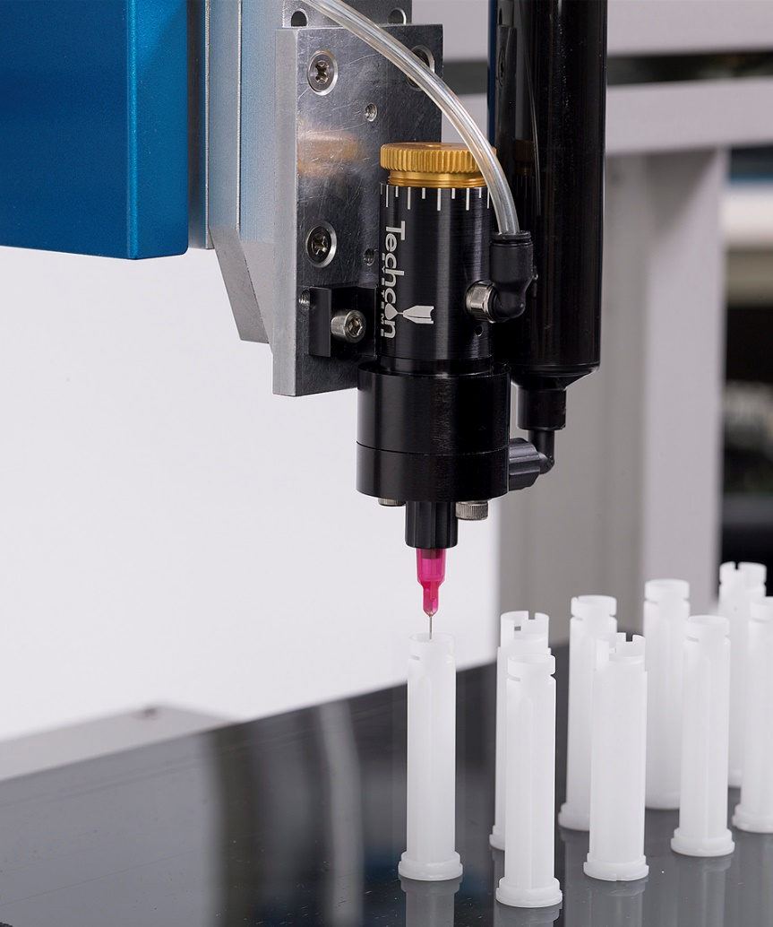

The valve comes with the following items:

* Mounting bracket kit
* Valve air hose
* Luer lock fluid line
* Sample packet of DMP inserts
* Dispensing tip selection pack

**TYPICAL APPLICATIONS**

* Dispensing pre-mixed 2-part epoxy.
* Dispensing Cyanoacrylate in bonding applications
* Applying a of UV lacquer in CD/DVD spin coating applications

**USA & Canada +1 714 230 2398 Europe +44 2380 489 100 Asia +86 21 64952662** [**www.techconsystems.com**](http://www.techconsystems.com)

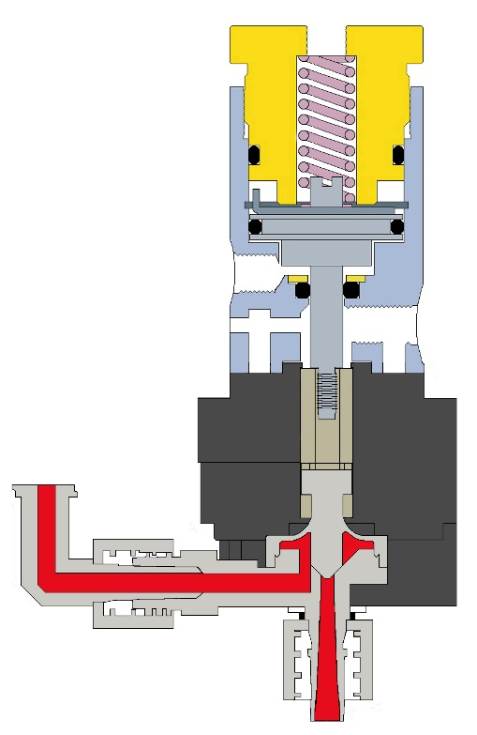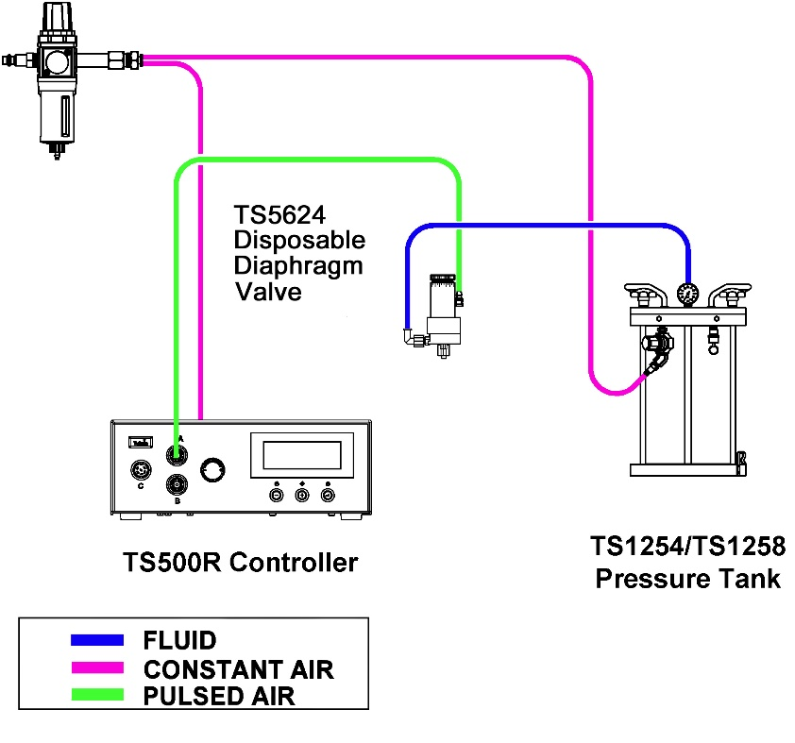

Air Cylinder

Flow Control

Adjustment

Luer Lock

**TYPICAL SETUP**

**TYPICAL SETUP**

Actuating

Air Input

Piston

Actuator

Fluid Inlet

DMP

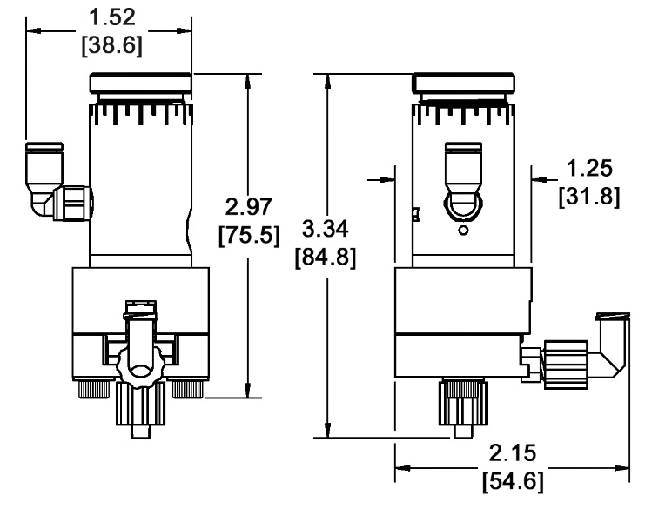

|  |  |  |
| --- | --- | --- |
| Part Number: |  | **TS5624DMP** |
| Size” |  | See drawing |
| Weight: |  | 0.25 lb (113g) |
| Fluid Inlet Port: |  | Luer lock female |
| Fluid Outlet Port |  | Luer lock male |
| Aux Air Inlet Port: |  | 10-32 UNF female |
| Activation Pressure Range: |  | 70 psi - 90 psi  (4.8bar - 6.2bar) |
| Max Fluid Pressure: |  | 60 psi (4.1bar) |
| Operating Frequency: |  | 400+ cycles/min. |
| Mounting Port: |  | 10-32 UNF female |
| Viscosity Range: |  | 1 - 50 000cps |
| Wetted Parts: |  | Black Polyethylene Compound |
|  |  |  |

**SPECIFICATIONS & PART NUMBERS**

Dimensions are in inches [mm]

**ACCESSORIES**

**For Sales and Support:**

**Techcon Systems Corporate Headquarters,**

**12151 Monarch Street, Garden Grove, California, 92841, USA.**

**Tel: 1-714-230-2398, Fax: 1-714-230-2393**

**E-mail:** [**oemorders@okinternational.com**](mailto:oemorders@okinternational.com)

**Techcon Systems European Corporate Office,**

**Eagle Close, Chandler’s Ford Industrial Estate,**

**Eastleigh, Hampshire, SO53 4NF, UK.**

**Tel: +44 2380 489 100, Fax: +44 2380 489 109**

**E-mail:** [**europe-orders@okinternational.com**](mailto:europe-orders@okinternational.com)

**Or visit** [**www.techconsystems.com**](http://www.techconsystems.com)

* **Replacement DMP Insert:** DMP-5624
* **Syringe Bracket:** P/N 7509-9100 fits all syringe sizes.
* **Fluid Reservoirs:** The valve can be fed from the TS1254 or TS1258 Pressure Tank, or from any size syringe or cartridge.
* **Dispense Tip:** For complete dispense tip selection please visit www.techconsystems.com

**WHAT’S IN THE BOX?**



Version 1.00

**LOCAL DISPENSING SOLUTIONS WORLDWIDE**